# Software Testing Assignment Module

## Module–2(Manual Testing)

• **What is Exploratory Testing?**

* Exploratory testing is an approach to software testing that is often described as simultaneous learning, test design and execution. EP aims to optimize and improve the software in every possible way. Types-
* 1. Structured testing :- Functionalities are checked in a structured mananer.
* 2. Exploratory testing :- Functionalities are checked in a ad-hoc manner or randomly.

• **What is traceability matrix?**

* Traceability matrix is table document matrix it is used in development software application to trace a requirements.
* Traceability types:

1.FORWARD TRACEABILITY

2.BACKWARD TRACEABILITY

3.BI-DIRECTIONAL TRACEABILITY

• **What is Boundary value testing?**

* Boundary value analysis(BVA) is a software testing technique in which tests are designed to include representatives of boundary values in a range. In this near by value is validated.

• **What is Equivalence partitioning testing?**

* Equivalence partitioning (EP) is a testing technique that divides the input space of a s/w component or system into partitions or classes of equivalent input values. There are two partition for testing.

• **What is Integration testing?**

* Integration testing is a testing process where individual units are combined and tested as a group.

Types of integration testing

1. Component integration testing

2. System integration testing

• **What determines the level of risk?**

* Risk A factor that could result in future negative consequences, usually expressed as impact and likelihood.

Type of Risk:

1.Project Risk

2.Product Risk

• **What is Alpha testing?**

* Alpha Testing is a type of software testing performed to identify bugs before releasing the product to real users or to the public. Alpha Testing is one of the user acceptance tests. It is the first stage of software testing, during which the internal development team tests the program before making it available to clients or people outside the company. Primarily focuses on identifying major bugs, system stability, and core functionalities. It is always performed by the developers at the software development site. It is conducted for the software application and project. It is form of acceptance testing. It comes under the category of both white box testing and black box testing.

• **What is beta testing?**

* Beta Testing is performed by real users of the software application in a real environment. Beta testing is one type of User Acceptance Testing. A pre-release version of the product is made available for testing to a chosen set of external users or customers during the second phase of software testing. It is not performed by independent testing team. Beta testing is always open to the market and public. It is usually conducted for software product. It is only a kind of black box testing.

• **What is component testing?**

* The testing of individual software components. Sometimes known as UNIT TESTING, MODULE TESTING OR PROGRAM TESTING.
* Unit testing are typically written and run by software developers.
* Unit testing is performed by using the white box testing method.
* Unit tests find problems early in the development cycle.

• **What is functional system testing?**

* Testing based on an analysis of the specification of the functionality of a component or system.
* Specification – e.g. requirements specification, use cases, functional specification or maybe undocumented.
* Function – what the system does
* Types – 1. Unit testing 2. Smoke testing 3. Sanity testing 4. Integration testing 5. White box testing 6. Black box testing 7. User acceptance testing 8. Regression testing

• **What is Non-Functional Testing?**

* Testing the attributes of a component or system that do not relate to functionality.
* E.g. reliability, efficiency, usability, interoperability, maintainability and portability.
* Types – 1. Performance testing 2. Load testing 3. Volume testing 4. Stress testing 5. Security testing 6. Installation testing 7. Penetration testing 8. Compatibility testing 9. Migration testing.

• **What is GUI Testing?**

* **GUI Testing** is a software testing type that checks the Graphical User Interface of the Software. The purpose of Graphical User Interface (GUI) Testing is to ensure the functionalities of software application work as per specifications by checking screens and controls like menus, buttons, icons, etc. GUI is what the user sees. Say if you visit guru99.com what you will see say homepage it is the GUI (graphical user interface) of the site. A user does not see the source code. The interface is visible to the user. Especially the focus is on the design structure, images that they are working properly or not.

• **What is Adhoc testing?**

* Adhoc testing is a software testing performed without any specific test plan or predefined set of steps. Is an informal testing type with an aim to break the system.
* Also known as random testing, error guessing and monkey testing.
* Types of Adhoc testing:- 1. Buddy testing 2. Pair testing 3. Monkey testing.

• **What is load testing?**

* It’s a performance testing to check system behavior under load. Testing an application under heavy loads, such as testing of web site under arrange of loads to determine at what point the system’s response time degrades or fails.
* Load testing is a kind of performance testing which determines a system’s performance under real-life load conditions.

**• What is stress Testing?**

* Stress testing is used to test the stability & reliability of the system. Its performed under heavy load like putting large number beyond storage capacity, complex database queries, continuous input to system or database load. It is also known as endurance testing/spike testing/traffic testing. Most prominent use of stress testing is to determine the limit, at which the system or software or hardware breaks.
* Types of stress testing:- 1.application stress testing 2.transactional stress testing 3.systemic stress testing 4. Exploratory stress testing

**• What is white box testing and list the types of white box testing?**

* Testing based on an analysis of the internal structure of the component or system. It is also known as White-box or Glass-box and Structure-based testing.
* Types of white box testing:- 1. Statement coverage 2. Decision coverage 3. Condition coverage.

• **What is black box testing? What are the different black box testing techniques?**

* Testing, either functional or non-functional, without reference to the internal structure of the component or system.
* Specification-based testing techniques is also known as ‘black – box’ or input/output driven testing techniques because they view the software as a black-box with inputs and outputs.
* Techniques of Black – Box Testing

1. Equivalence partitioning
2. Boundary value analysis
3. Decision tables
4. State transition testing

• **Mention what are the categories of defects?**

* Data Quality/ Database Defects
* Critical functionality defects
* Functionality defects
* Security defects
* User interface defects

• **Mention what big bang testing is?**

* Big Bang testing is testing approach where all components or modules are integrated and tested as a single unit or whole.
* Big Bang testing has the advantage that everything is finished before integration testing starts.
* Major disadvantage is time consuming and difficult to trace the cause of failures because of this late integration.

• **What is the purpose of exit criteria?**

* Executed test cases are documented
* All high prioritized bugs are fixed and closed
* Limitations
* Technical documents to be submitted followed by release notes

• **When should "Regression Testing" be performed?**

* Regression testing is doing at the time when your software application it undergoes a code change to ensure that the new code has not affected other parts of the software
* Regression testing is performed due to some of this reason which are given below
* New feature is added to the software.
* Defect fixing
* Performance issue fix
* When code is modified according to requirement
* When requirement is change

• **What is 7 key principles? Explain in detail?**

* TESTING SHOW PRESENCE OF DEFECTS

Testing can show that defects are present, but cannot prove that there are no defects.

We test to find faults

However testing cannot prove that there are no defects present

* EXHAUSTIVE TESTING IS IMPOSSIBLE

Testing everything including all combination of inputs and preconditions is not possible

So, instead of doing the exhaustive testing we can use risk and priorities to focus testing efforts

* EARLY TESTING

Testing activities should start as early as possible in the software or system development life cycle.

Testing activities should be focused on defined objectives-oulined in the test strategy.

Remember from our definition of testing, that testing doesn’t start once the code has been written.

* DEFECT CLUSTERING

A small number of modules contain most of the defects discovered during pre release testing, or responsible for the most operational failures.

* PESTICIDES PARADOX

The pesticide paradox says that if the same tests are repeated over and over again, eventually, the same set of test cases will no longer identify any new bugs in the system.

* TESTING IS CONTAXT DEPENDANT

The methods and types of testing carried out can completely depend on the context of the software or systems.

• **Difference between QA v/s QC v/s Tester**

|  |  |  |
| --- | --- | --- |
| QA | QC | Testing |
| QA is known as Quality Assurance | QC is known as Quality Control | Testing is testing |
| Focus on process and procedures rather than actual testing. | Focus on actual testing. | Focus on actual testing |
| Process Oriented Activities | Product Oriented Activities | Product Oriented Activities |
| Preventive Activities | Corrective Process | Preventive Process |
| QA is subset of STLC(software test life cycle) | QC is subset of QA | Testing is subset of QC |

•**Difference between Smoke and Sanity?**

|  |  |  |
| --- | --- | --- |
| SR.NO | SMOKE | SNATIY |
| 1 | Smoke testing is performed to ascertain that the critical functionalities of the program is working fine. | sanity testing is done to check the new functionality/bugs have been fixed. |
| 2 | The objective of the testing to verify “stability” of the system in order to the proceed with more rigorous testing. | The objective of the testing is to verify the “rationality” of the system in order to the proceed with more rigorous testing. |
| 3 | This testing is performed by the developers or testers. | Sanity testing is usually performed by testers. |
| 4 | Smoke testing is usually documented or scripted. | Sanity testing is usually not documented and unscripted. |
| 5 | Smoke testing is subset of regression testing. | Sanity testing is subset of acceptance testing. |
| 6 | Smoke testing exercises the entire system from end to end. | Sanity testing exercises only the particular component of the entire system. |
| 7 | Smoke testing is like general health checkup. | Sanity testing is like specialized health checkup. |

• **Difference between verification and Validation**

|  |  |  |
| --- | --- | --- |
| SERIES | VERIFICATION | VALIDATION |
| 1 | Verification is static | Validation is dynamic |
| 2 | Verification has the development level | Validation has the test level |
| 3 | Before the coding verification | After the coding validation |
| 4 | Are we building the product right? | Are we building the right product? |
| 5 | Types   * Business requirement * System design/ requirement * Architectural design (technical specification) * Module design(program specification) | Types   * Unit testing * Integration testing * System testing * Acceptance testing |
| 6 | Activities   * Review * Walkthroughs * Inspections | Testing |
| 7 | Evaluation items   * Plans * Requirement specs * Design specs * Code * Test cases | The actual product/software. |

• **Explain types of Performance testing**

* Performance testing is means of quality assurance(QA). It involves testing software applications to ensure they will perform well under their expected workload.
* The focus of performance testing is checking a software programs
* Speed- Determines whether the application responds quickly.
* Scalability – Determines maximum user load the software application can handle.
* Stability – Determines if the application is stable under varying loads.
* Types of performance testing:-
* Load testing :- Confirms that the system can handle the required number of users and still operate at a high level of performance
* Stress testing :-Intentionally tries to break the software by simulating a number of users that greatly exceeds expectations
* Endurance testing :-Endurance testing evaluates the performance of the system under load over time**.**
* Spike testing :- This testing evaluates the ability of the application to handle sudden volume increases.
* Volume testing :-Checks that the software can handle and process a large amount of data at once without breaking, slowing down or losing any information.
* Scalability testing :-This testing is used to determine your application’s ability to handle increasing amounts of load and processing.

•. **What is Error, Defect, Bug and failure?**

* Error :- Finding mistake in coding its called Error.
* Defect :- Error finds by the tester its called defect.
* Bug :- defects are accepted by developer team its called bug.
* Failure :- requirements are not fulfilled its called failure.

• **Difference between Priority and Severity**

|  |  |  |
| --- | --- | --- |
| SRNO. | PRIORITY | SEVERITY |
| 1 | Defect Priority has defined the order in which the developer should resolve a defect | Defect Severity is defined as the degree of impact that a defect has on the operation of the product |
| 2 | Priority is associated with scheduling | Severity is associated with functionality or standards |
| 3 | Priority indicates how soon the bug should be fixed | Severity indicates the seriousness of the defect on the product functionality |
| 4 | Priority of defects is decided in consultation with the manager/client | QA engineer determines the severity level of the defect |
| 5 | Priority is driven by business value | Severity is driven by functionality |
| 6 | Its value is subjective and can change over a period of time depending on the change in the project situation | Its value is objective and less likely to change |
| 7 | High priority and low severity status indicates, defect have to be fixed on immediate bases but does not affect the application | High severity and low priority status indicates defect have to be fixed but not on immediate bases |
| 8 | Priority status is based on customer requirements | Severity status is based on the technical aspect of the product |
| 9 | During UAT the development team fix defects based on priority | During SIT, the development team will fix defects based on the severity and then priority |
| 10 | Priority is categorized into three types  Low  Medium  High | Severity is categorized into five types  Critical  Major  Moderate  Minor  Cosmetic |

• **What is Bug Life Cycle?**

* The bug life cycle in testing refers to a cycle of defects in which it goes through different states throughout its life.

NEW

DUPLICATE

ASSIGNED

REJECTED

OPEN

DEFFERED

FIXED

NOT A BUG

PENDING RETEST

REOPENED

RETEST

VERIFIED

CLOSED

• **Explain the difference between Functional testing and NonFunctional testing**

|  |  |  |
| --- | --- | --- |
| SERIES | FUNTIONAL TESTING | NON-FUNTIONAL TESTING |
| 1 | Functional testing is performed using the functional specification provided by the client and verifies the system against the functional requirements, | Non-Functional testing checks the performance, reliability, scalability and other non-functional aspects of the software system. |
| 2 | Functional testing is executed first. | Non-functional testing should be performed after functional testing. |
| 3 | Manual testing or automation tools can be used for functional testing. | Using tools will be effective for this testing. |
| 4 | Business requirements are the inputs to functional testing. | Performance parameters like speed, scalability, are inputs to non-functional testing. |
| 5 | Functional testing describe what the product does. | Non-functional testing describes how good the product works. |
| 6 | Easy to do manual testing | Tough to do manual testing |
| 7 | Types of functional testing:-   * Unit testing * Smoke testing * Sanity testing * Integration testing * White box testing * Black box testing * User acceptance testing * Regression testing | Types of non-functional testing:-   * Performance testing * Load testing * Volume testing * Stress testing * Security testing * Installation testing * Penetration testing * Compatibility testing * Migration testing |
|  | | |

• To create HLR & TestCase of 1)(Instagram , Facebook) only first page 2) Facebook Login Page: <https://www.facebook.com/>

• **What isthe difference between the STLC (Software Testing Life Cycle) and SDLC (Software Development Life Cycle)?**

|  |  |  |  |
| --- | --- | --- | --- |
| SERIES | SDLC(software development life cycle) | | STLC(software test life cycle) |
| 1 | STDC is mainly related to software development. | | STLC is mainly related to software testing. |
| 2 | Besides development other phases like testing is also included. | | It focuses only on testing the software. |
| 3 | SDLC involves totsl six phases or steps.   * Requirement gathering * Analysis * Design * Implementation * Testing * Maintenance | | STLC involves total six phases or steps.   * Requirement analysis * Test planning * Test case development * Test environment setup * Test execution * Test cycle closure |
| 4 | In SDLC more number of member (developers) are required for the whole process. | | In STLC less number of members (testers) are needed. |
| 5 | In SDLC development team makes the plans and designs based on the requirements. | | In STLC testing team (test lead or test architect) makes the plans and designs. |
| 6 | Goal of SDLC is to complete successful development of software. | | Goal of STLC is to complete successful testing of software. |
| 7 | It helps in developing good quality software. | | It helps in making the software defects free. |
| 8 | | SDLC phases are completed before the STLC phases. | STLC phases are performed after SDLC phases. |
| 9 | | Creation of reusable software is the end result of SDLC. | A tested software system is end result of STLC. |
| 10 | | Post deployment support, enhancement and update are to be included if necessary. | Regression tests are run by QA team to check deployed maintenance code and maintains test cases and automated scripts. |

• **What is the difference between test scenarios, test cases, and test script?**

|  |  |  |  |
| --- | --- | --- | --- |
| SR. NO. | TEST SCENARIO | TEST CASES | TEST SCRIPT |
| 1. | It is a process to test an application with all possible ways. | it is a step by step by procedure that is used to test an application. | it is a set of instructions to test an application automatically. |
| 2. | Test scenario are an input for the creation of test cases. | the term test case is used in the manual testing environment. | The term test script is used in automation testing environment. |
| 3. | It reduces the complexity. | it is done manually | It is done by scripting format. |
| 4. | Test scenario can be a single or a group of test cases. | It is development in the form of templates | It is development in the form of scripting. |
| 5. | By writing scenarios it will be easy to understand the functionality of an application. | Test case templet includes test case ID, test data, test procedure, actual result, expected result etc. | In test script we can use different commands to develop script. |
| 6. | These are one-line statements to explain what we are going to test | It is a base form to test an application in sequence | Once we develop, the script will run it multiple times until the requirement is changed. |

• **Explain what** **Test Plan is? What is the information that should be covered**.

* A document describing the scope approach, resources, and schedule of intended test activities

Follow the seven steps below to create a test plan: -

1. Analyze the product
2. Design the test strategy
3. Define the test objectives
4. Define test criteria
5. Resource planning
6. Plan test environment
7. Schedule and estimation
8. Determine test deliverables

**• What is priority?**

* Priority is defined as the order in which a defect should be fixed. Higher the priority the sooner the defect should be resolved.
* Defects that leave the software system unusable are given higher priority over defects that cause a small functionality of the software to fail.
* Priority Types

Types of Priority of bug/defect can be categorized into three parts :

* **Low:**The Defect is an irritant but repair can be done once the more serious Defect has been fixed
* **Medium:**During the normal course of the development activities defect should be resolved. It can wait until a new version is created
* **High:**The defect must be resolved as soon as possible as it affects the system severely and cannot be used until it is fixed

**• What is severity?**

* Defect Severity in testing is a degree of impact a bug or a[Defect](https://www.guru99.com/defect-management-process.html)has on the software application under test. A higher effect of bug/defect on system functionality will lead to a higher severity level. A[Quality Assurance](https://www.guru99.com/all-about-quality-assurance.html)engineer usually determines the severity level of a bug/defect.
* Types of Severity

In [*Software Testing*](https://www.guru99.com/software-testing-introduction-importance.html), Types of Severity of bug/defect can be categorized into the following parts:

* **Critical**: This defect indicates complete shut-down of the process, nothing can proceed further
* **Major**: It is a highly severe defect and collapses the system. However, certain parts of the system remain functional
* **Medium**: It causes some undesirable behavior, but the system is still functional
* **Low**: It won’t cause any major break-down of the system

• **Bug categories are…**

1.Data quality/database defects: - deals with improper handling of data in the database.

Example: -

* values not deleted/inserted into the database properly.
* Improper/wrong/null values inserted in place of the actual value.

2. Critical functionality defects: - the occurrence of these bugs hampers the crucial functionality of the application.

Example: -

* Exceptions

3.functionality defects: - these defects affect the functionality of the application.

Example: -

* all java errors.
* Buttons like save, delete, cancel, not performing their intended functions.
* a missing functionality(or) a feature not functioning the way it is intended to continuous execution of loops.

4.Security defects: - application security defects generally involve improper handling of data sent from the user to the application.

These defects are the most severe and given highest priority for a fix.

Example:

* Authentication: - accepting an invalid username/password.
* Authorization: -accessibility to pages though permission not given.

5.User interface defects: - as the name suggests, the bugs deal with problems related to UI are usually considered less severe

Example:

* Improper error/warning/UI messages
* Spelling mistakes
* Alignment problems

• **Advantage of Bugzila .**

Advantages: -

* Open source, free bug tracking tool.
* Automatic duplicate bug detection.
* Search option with advanced features.
* File/modify/bugs by email
* Multiple authentication methods (LDAP, Apache server)
* Time tracking
* Automated bug reporting has an API to interact with system
* Integrated email capabilities.
* Robust security
* Powerful query tool
* Ideal for small projects
* Optimized database structure to enhance performance**.**

• **What** **are the different Methodologies in Agile Development Model?**

1. **Scrum** :- scrum is an agile development method which concentrates particularly on how to manage tasks within a team based development environment.

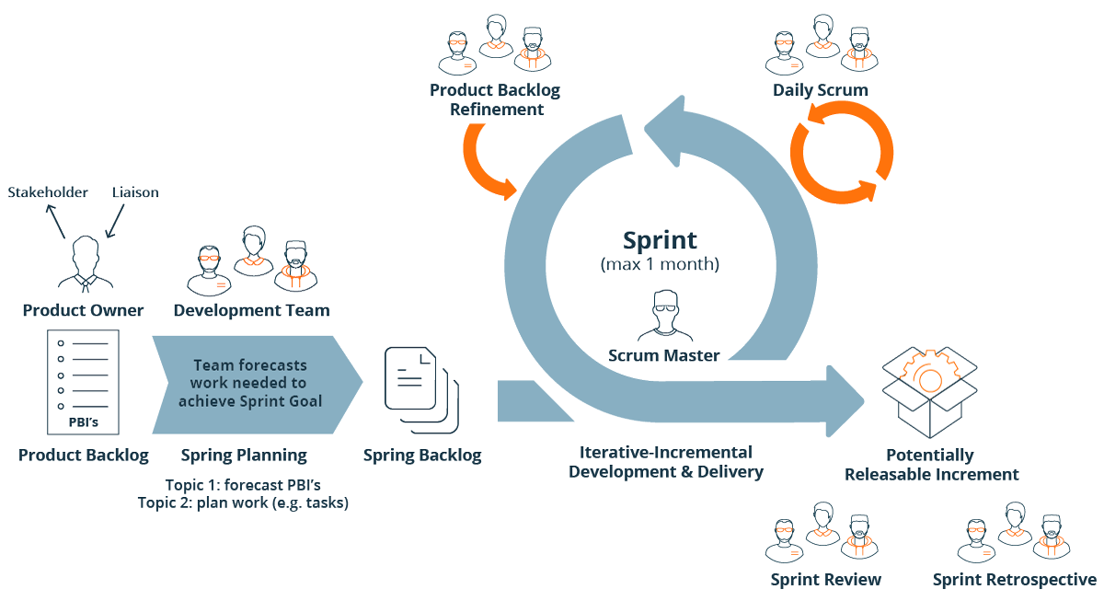

**Scrum master**: - master is responsible for setting up the team, sprint meeting and removes obstacles to progress

**Product owner**: - the product owner creates product backlog, prioritizes the backlog and is responsible for the delivery of the functionality at each iteration.

**Scrum team**: - team manages its own work and organizes the work to complete the sprint or cycle**.**

**2. kanban**

Kanban is a very popular framework for development in the agile software development methodology.

It provides a transparent way of visualizing the tasks and work capacity of a team.It mainly uses physical and digital boards to allow the team members to visualize the current state of the project they are working on.

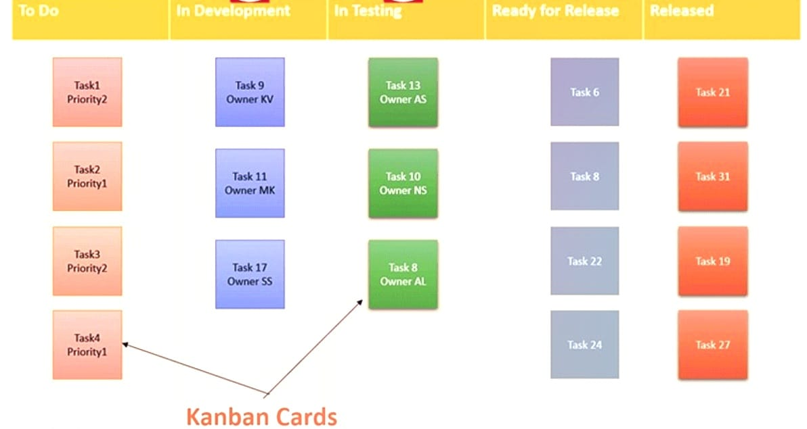

• **Explain the difference between Authorization and Authentication in Web testing.What are the common problems faced in Web testing?**

|  |  |  |
| --- | --- | --- |
| Sr.no | authentication | authorization |
| 1 | Authentication verifies who the user is. | Authorization determines what resources a user can access |
| 2 | Authentication works through password, one-time pins, biometric information and other information provide or entered by the user | Authorization works through setting that are implemented and maintained by the organization. |
| 3 | Authentication is the first step of a good identity and access management process | Authorization always takes place after authentication |
| 4 | Authentication is visible to and partially changeable by the user | Authorization isn’t visible to or changeable by the user |
| 5 | Example: - by verifying their identity, employees can gain access to a human resources (HR) application that includes their personal pay information, vacation time | Example: - once their level of access is authorized, employees and HR managers can access different levels of data based on the permissions set by the organization. |

One of the main challenges of web application testing is ensuring that your web app works well across different browsers, devices, and operating systems. Different browsers may have different rendering engines, standard support, features and extensions that can affect how your web app looks and behaves.

* **To create HLR & TestCase of WebBased (WhatsApp web , Instagram) 1. WhatsApp Web :** [**https://web.whatsapp.com/**](https://web.whatsapp.com/)

**• To create HLR and TestCase on this Link.** [**https://artoftesting.com/**](https://artoftesting.com/)

• **Write a scenario of only Whatsapp chat messages**

**• Write a Scenario of Pen**

**• Write a Scenario of Pen Stand**

**• Write a Scenario of Door**

**• Write a Scenario of ATM**

• **When to used Usablity Testing?**

* The parameters tested during usability testing are efficiency, effectiveness and satisfaction. If should be performed before any new design is made. This test should be iterated unless all the necessary changes have been made.

• **What is the procedure for GUI Testing?**

* Graphical user interface (GUI) testing is the process of testing the system’s GUI of the system under test. GUI testing involves checking the screens with the controls like menus, buttons, icons, and all types of bars- tool bar, menu bar, dialog boxes and windows etc.

**• Write a scenario of Microwave Owen**

**• Write a scenario of Coffee vending Machine**

**• Write a scenario of chair**

**• To Create Scenario (Positive & Negative) 2. Online shopping to buy product (flipkart)**

• **Write a Scenario of Wrist Watch**

**• Write a Scenario of Lift(Elevator)**

**• Write a Scenario of whatsapp Group (generate group)**

**• Write a Scenario of Whatsapp payment**